**Cloud and serverless computing**

**PROJECT: Toxicity Detector, Speech-To-Text with AWS Transcribe**

**Create role for API Gateway**:

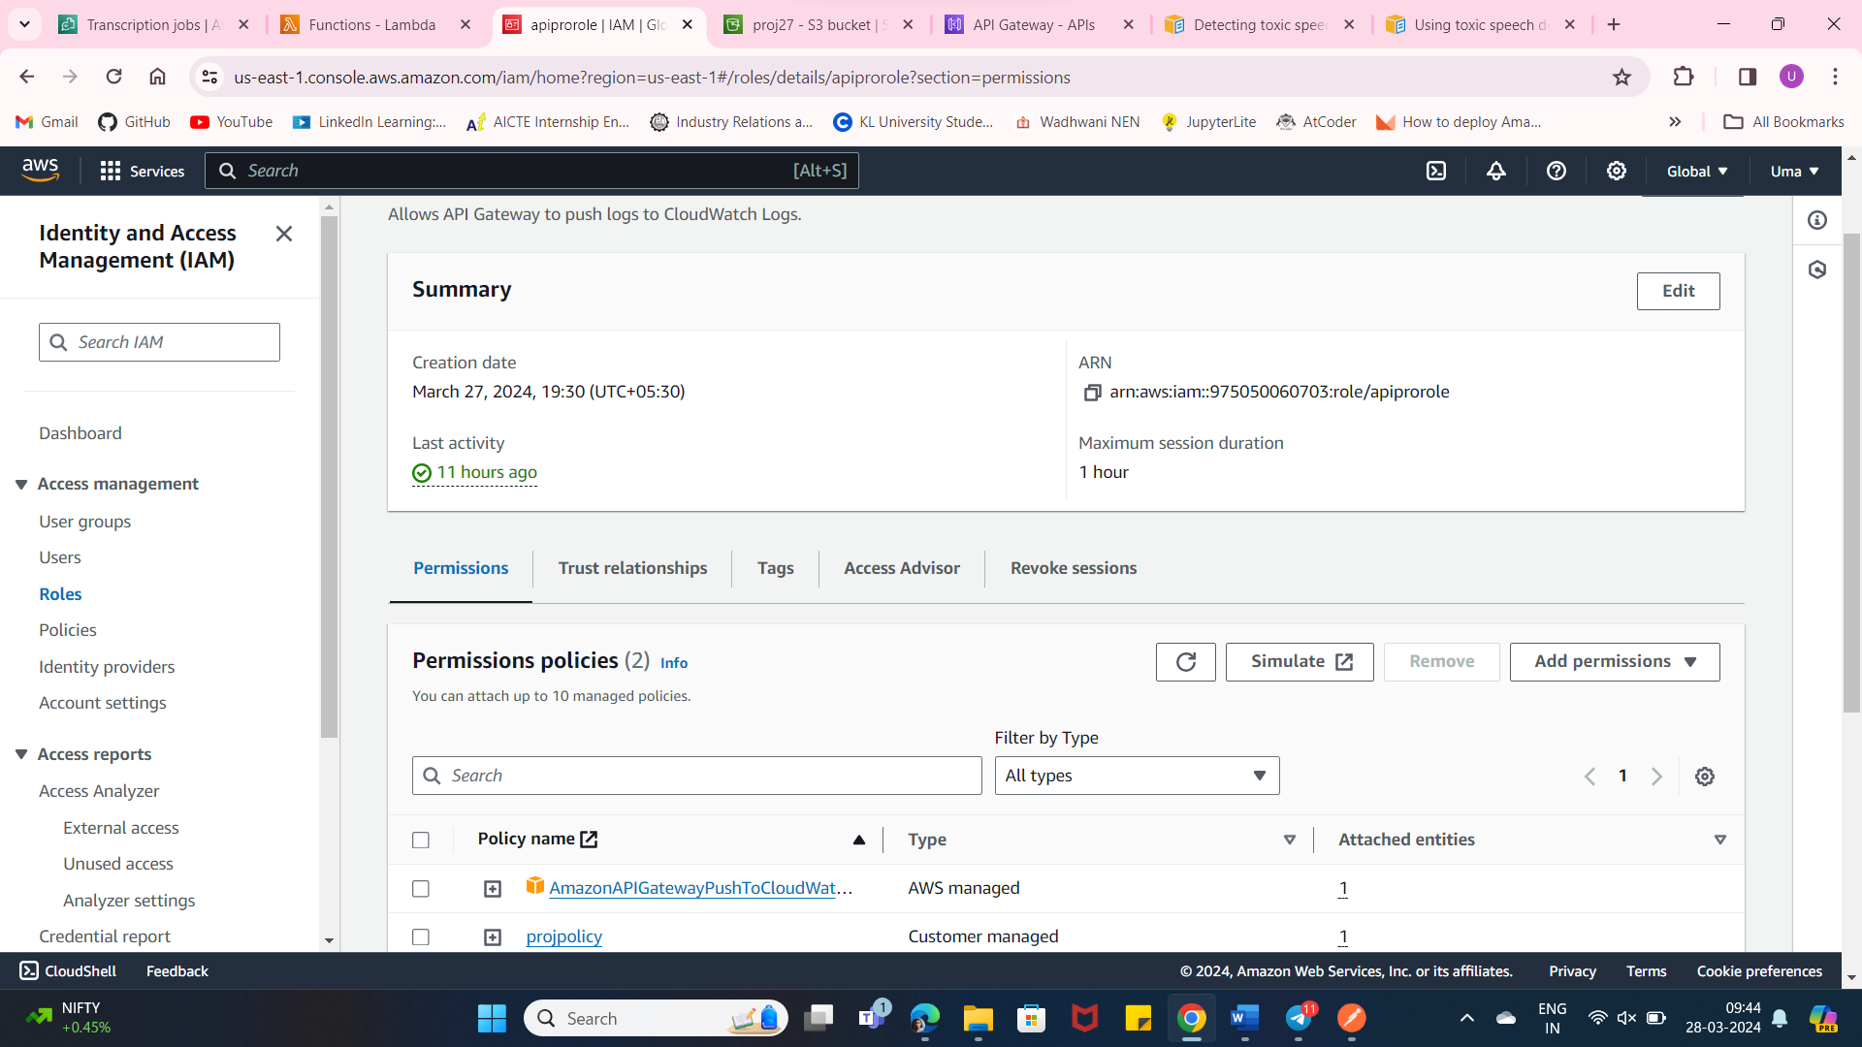

**Create a bucket for storing the files[audio] from api gateway:**

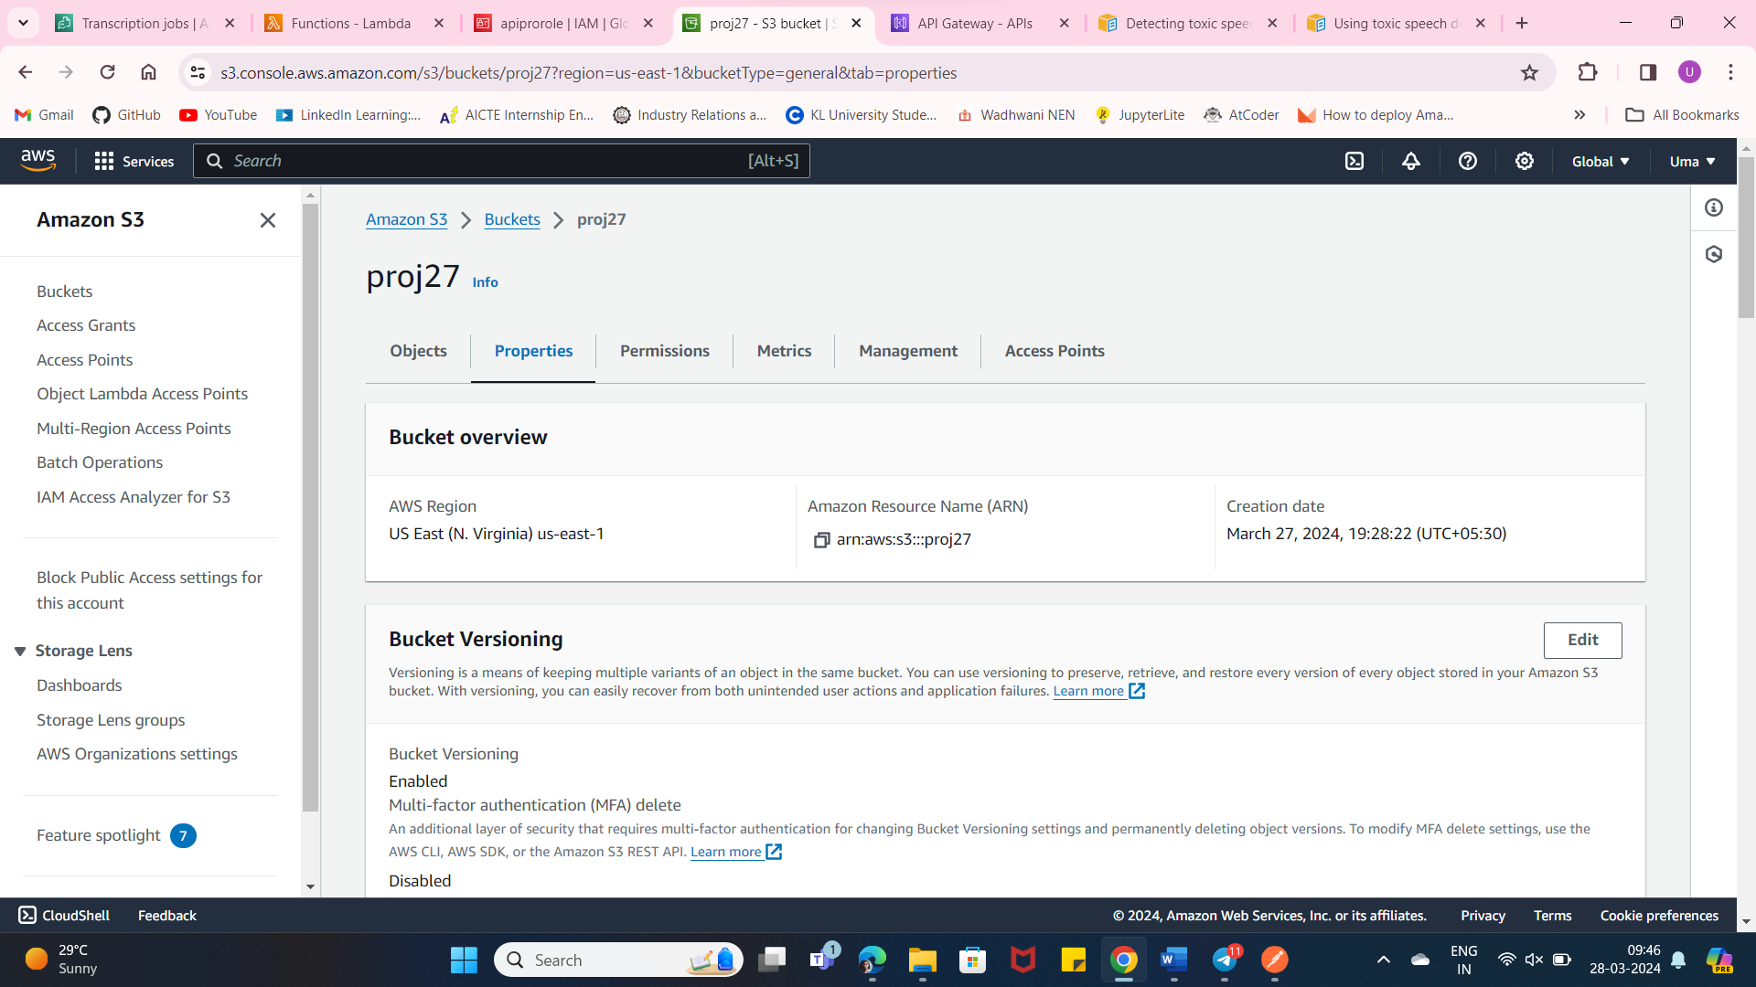

**Create a API Gateway [PUT METHOD] for uploading the files into s3 bucket:**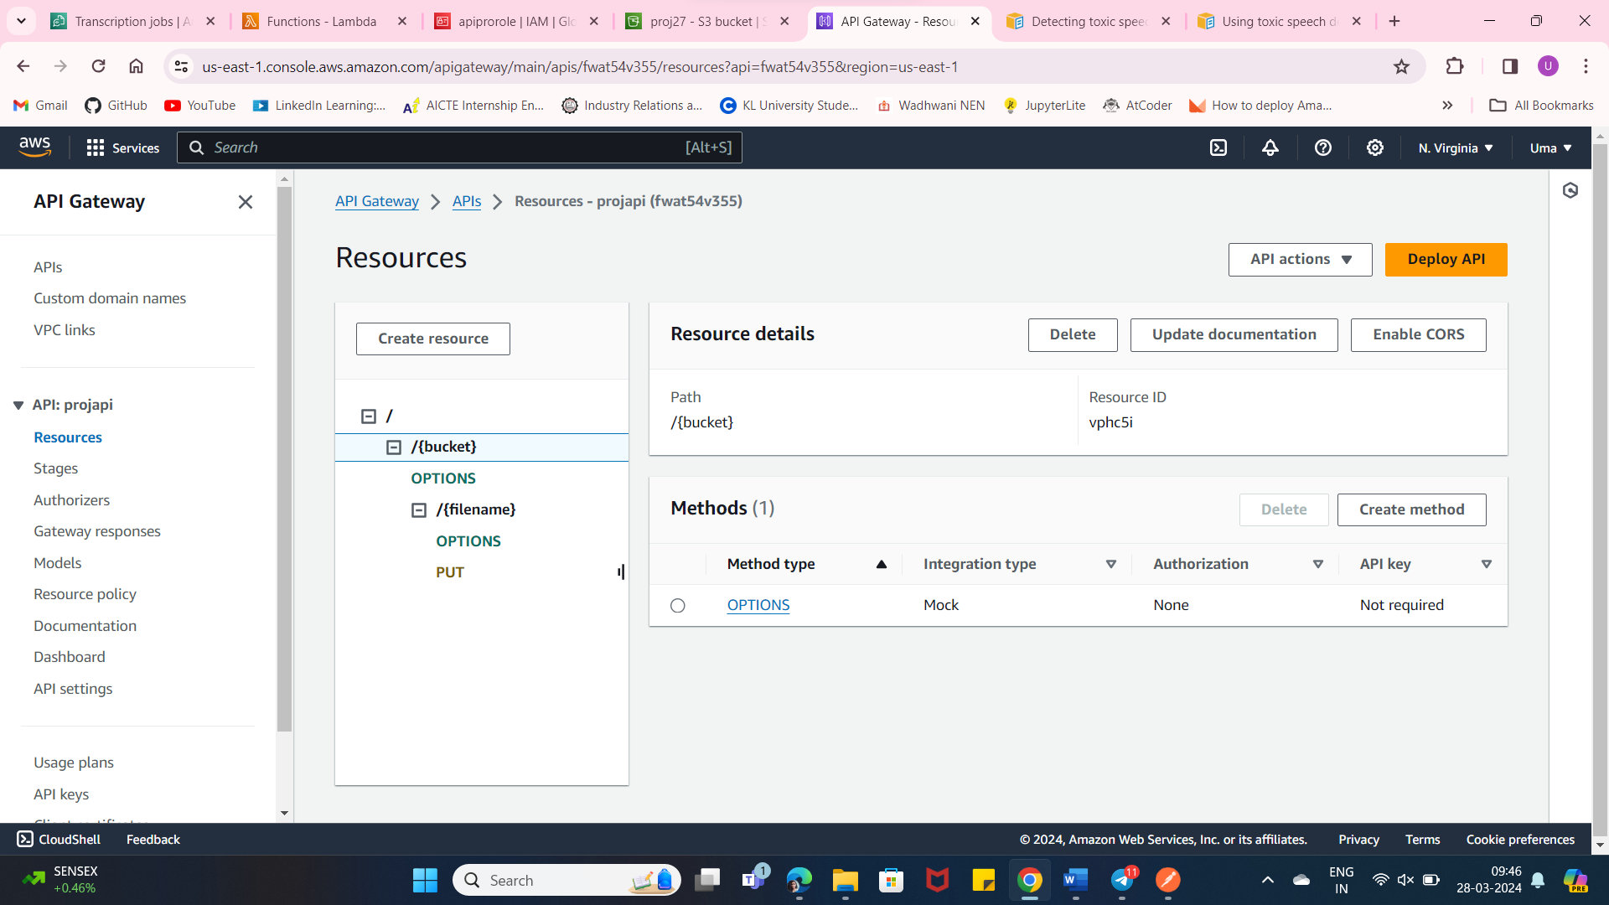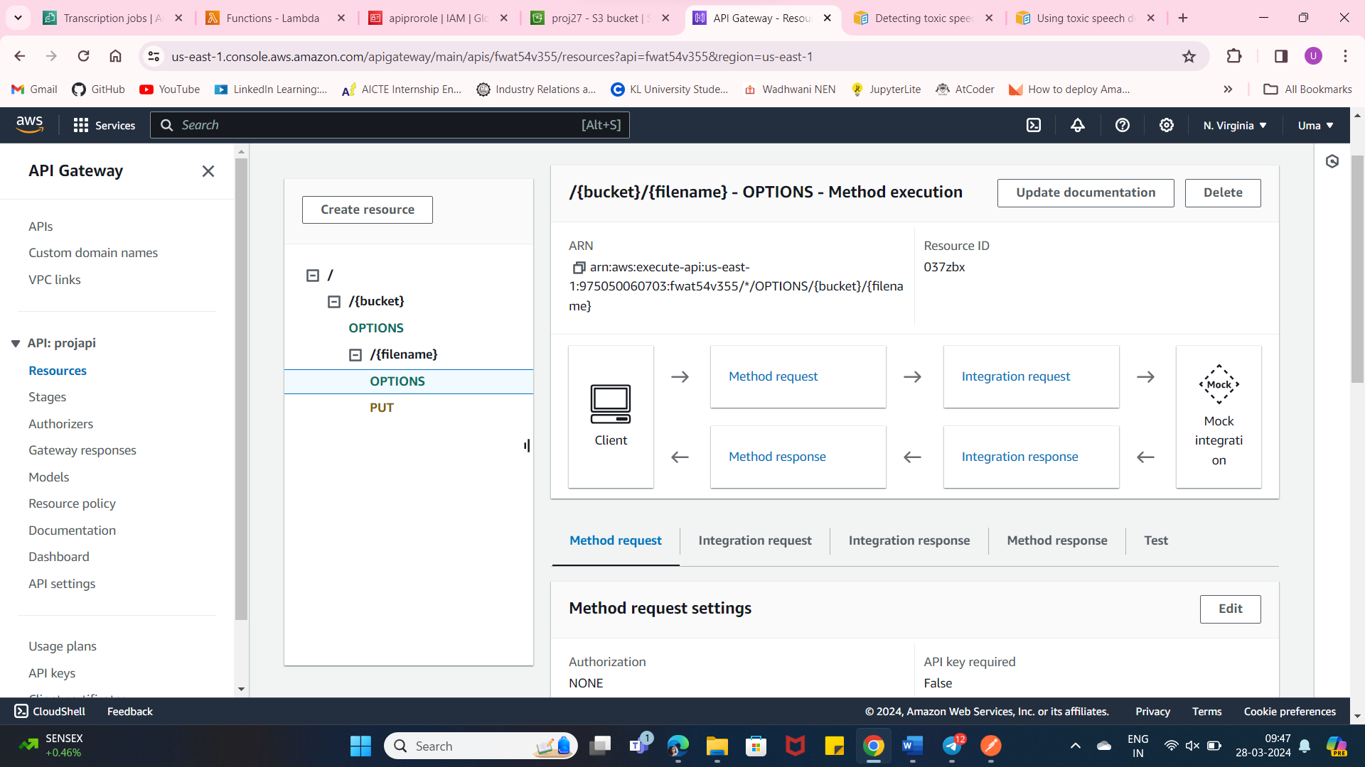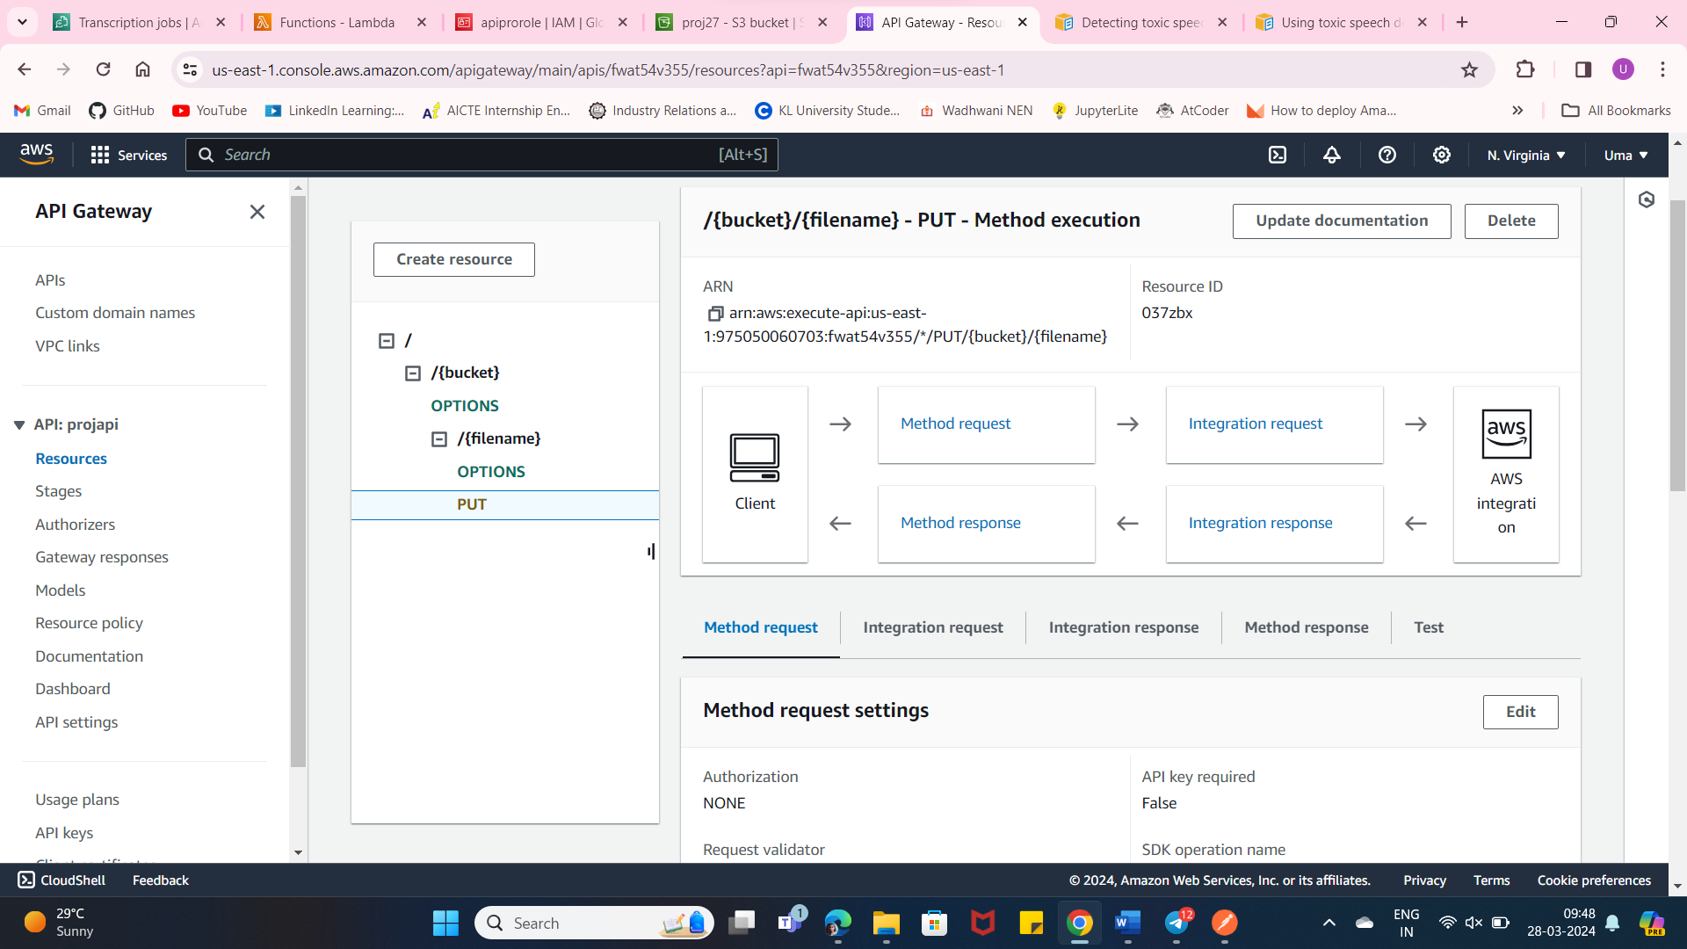

**Upload the file using postman api to the bucket:**

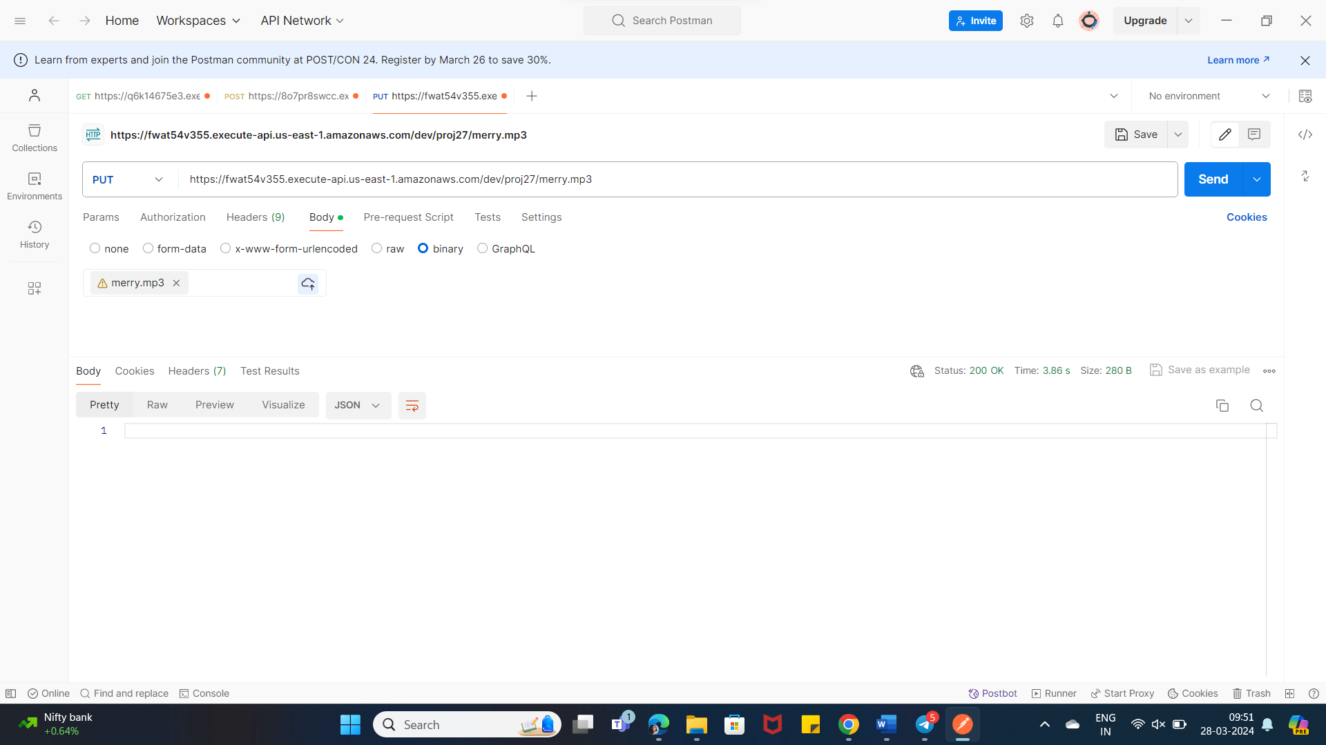

**It stores the file in the bucket:**

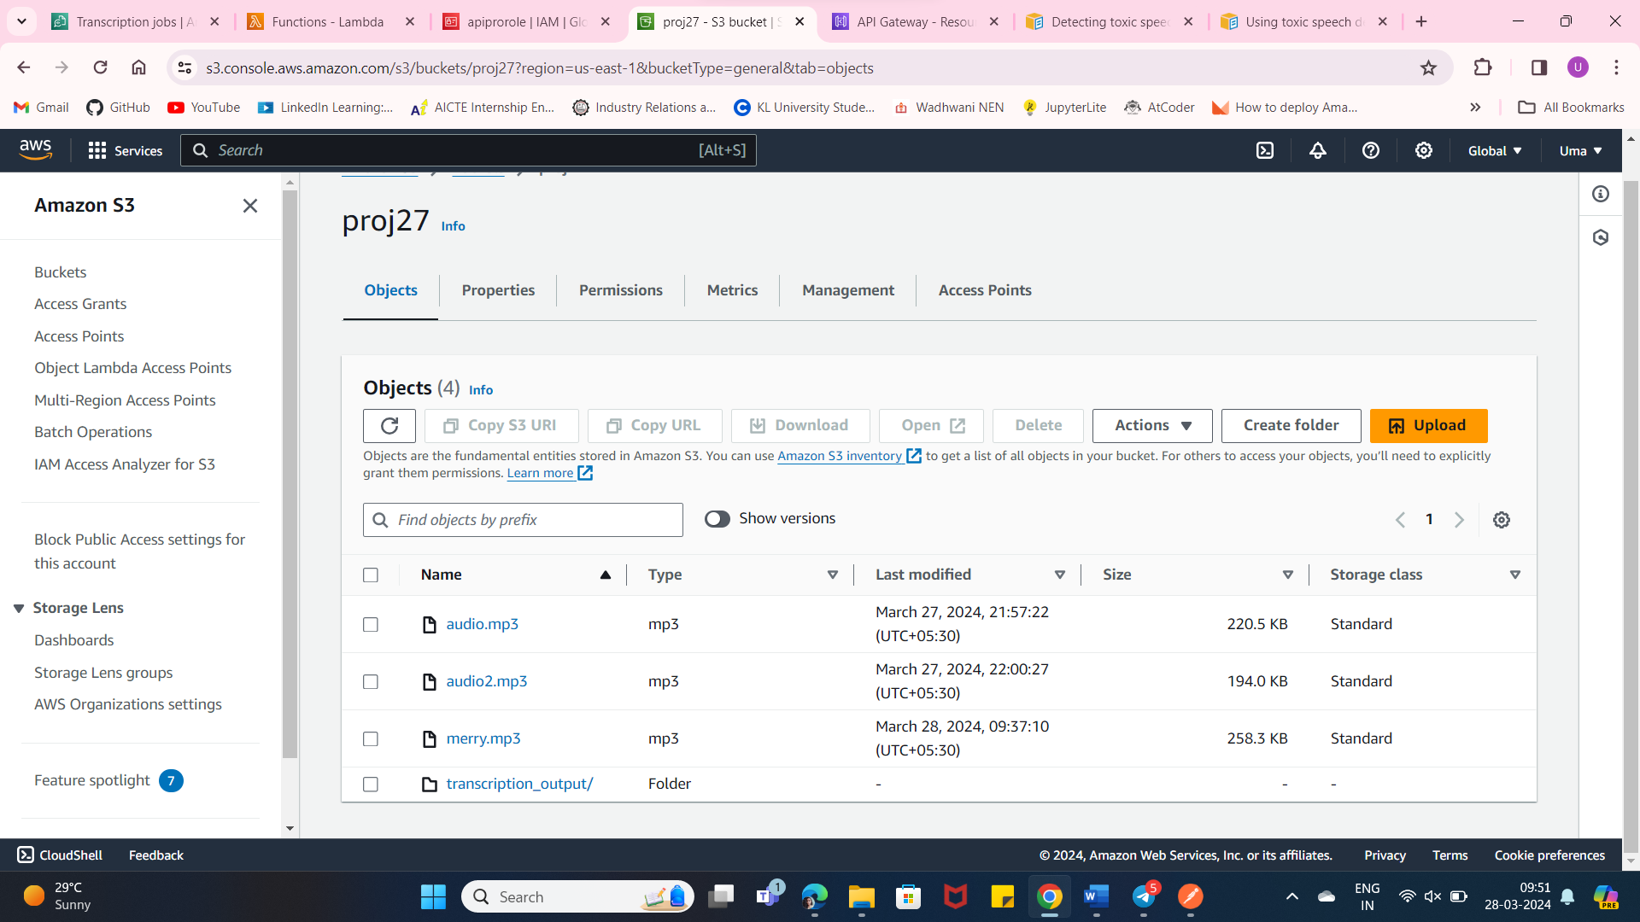

**Now create a role for –**

**AmazonS3FullAccess**

**AmazonTranscribeFullAccess**

**CloudWatchFullAccess**

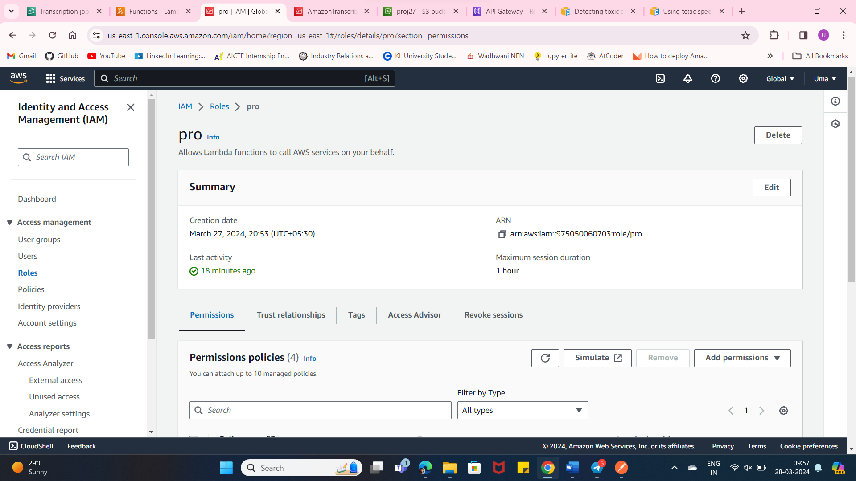

**Create a lambda function with Existing Role:**

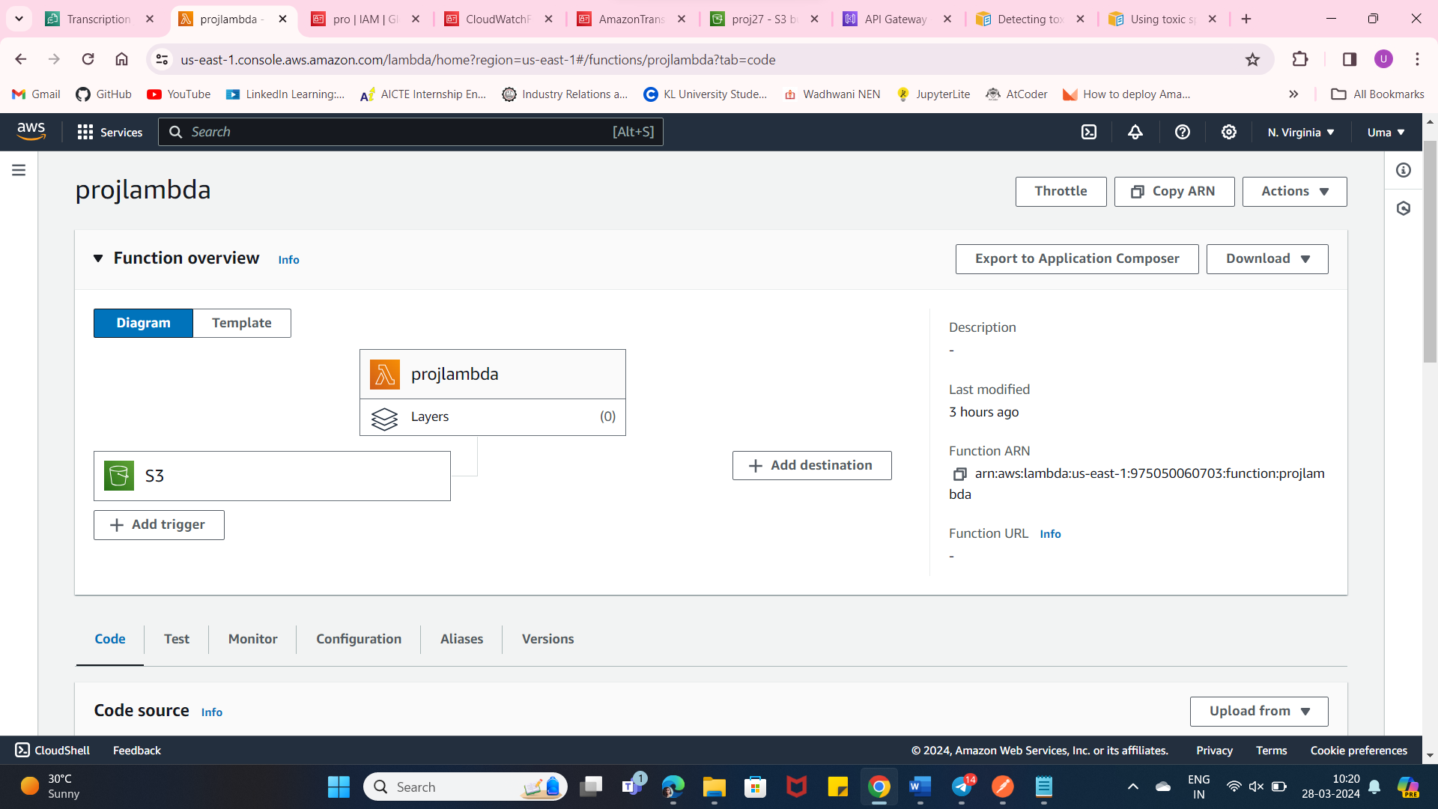

**Create an event Notification in s3 to know whenever an event occurs:**

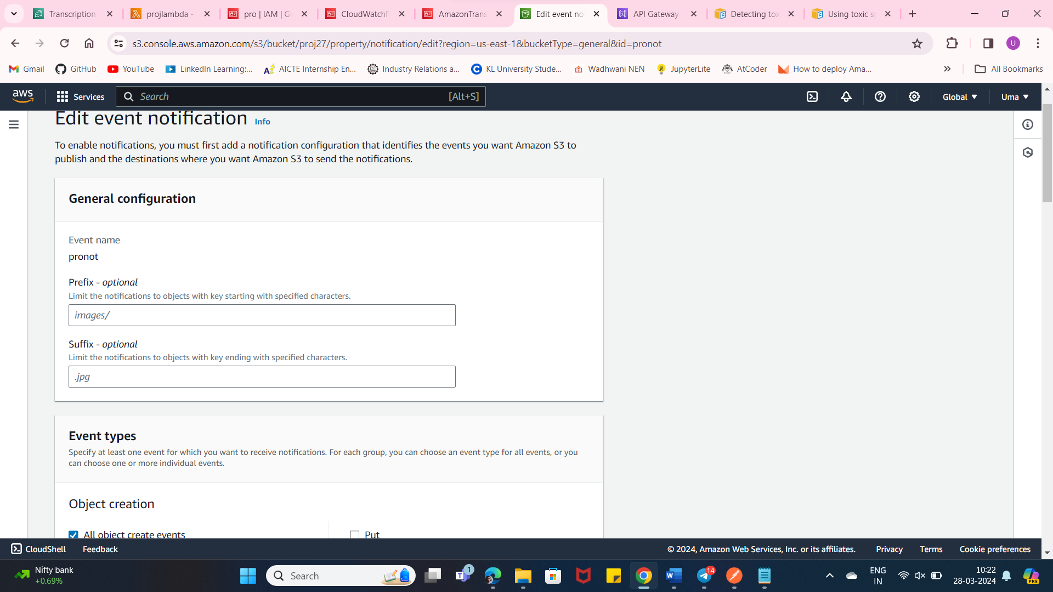

**Open cloudwatch to see the logs:**

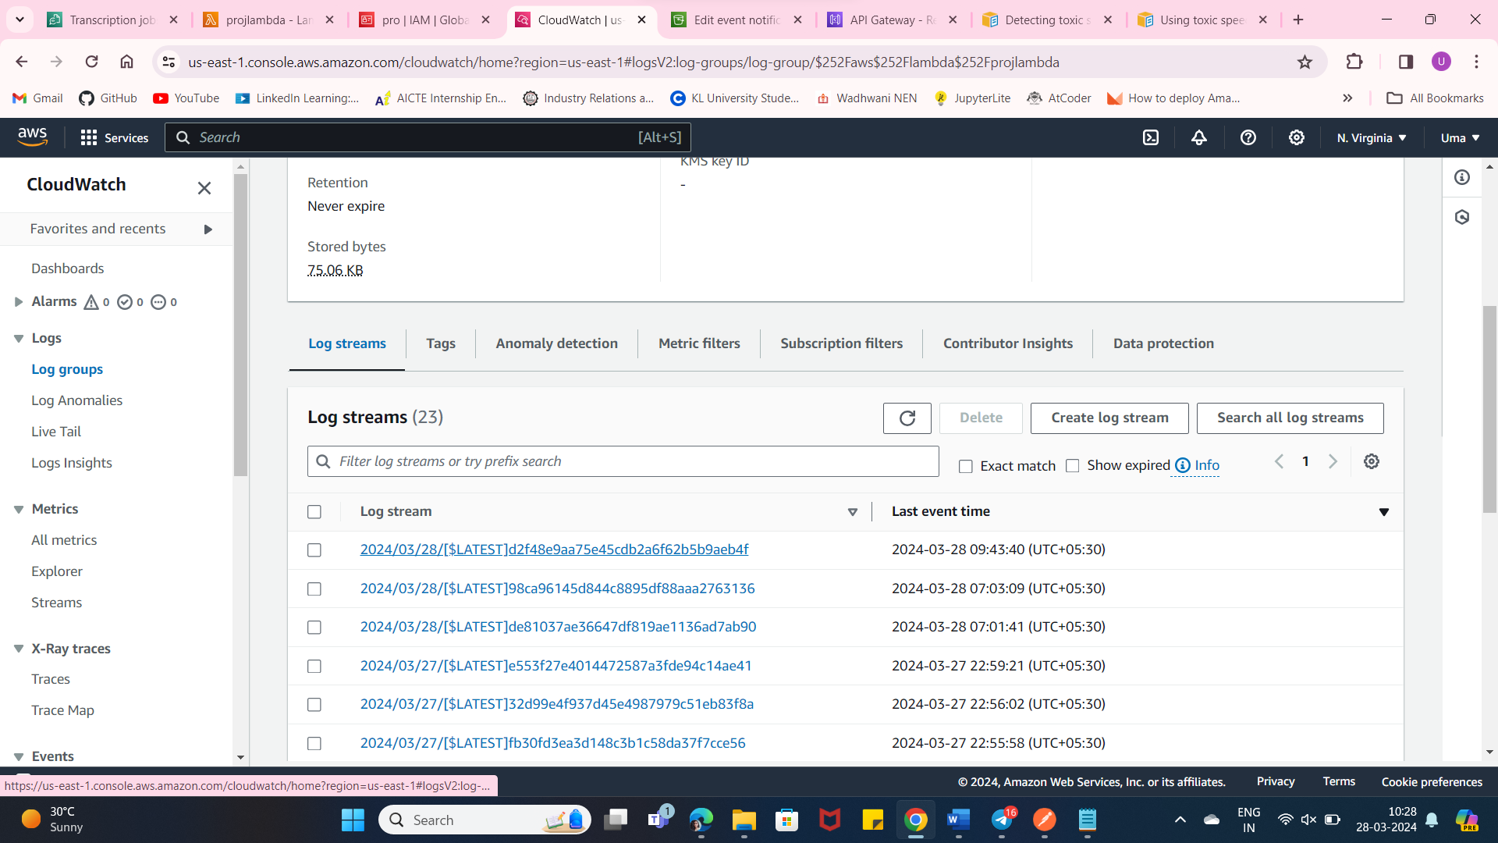

**Write the code in lambda and configure test event with the cloudwatch logs :**

**This code gets the object from s3 and starts a transcription job to convert the audio to text and toxicity detection:**

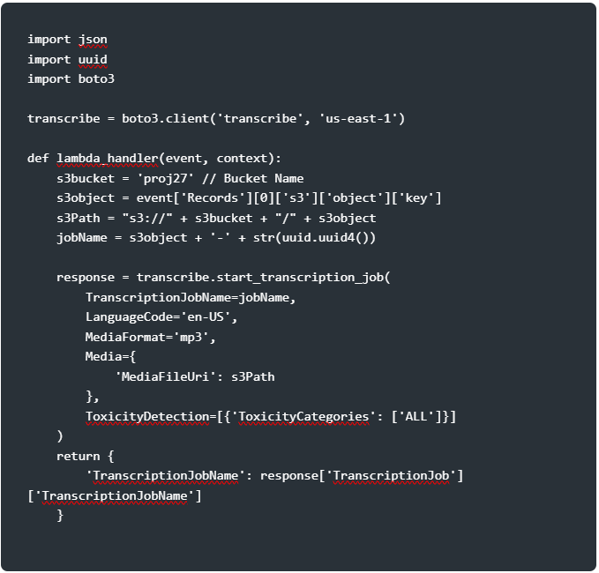

**Code for test event:**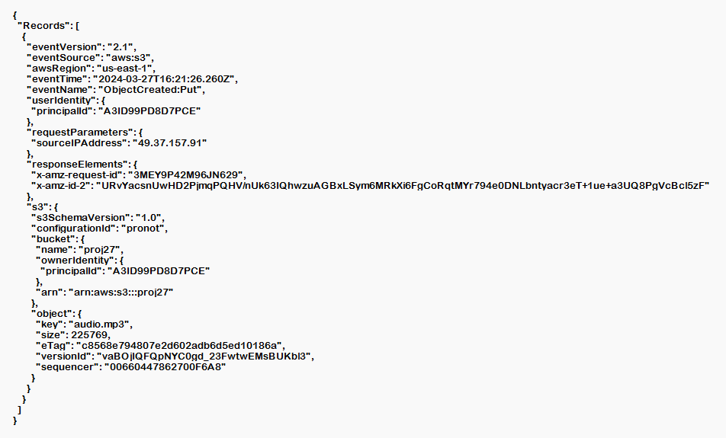

**Add a s3 trigger for lambda to dynamically start the transcription job:**

**It takes time to transcribe. Don’t forget to increase timeout sec to avoid errors:**

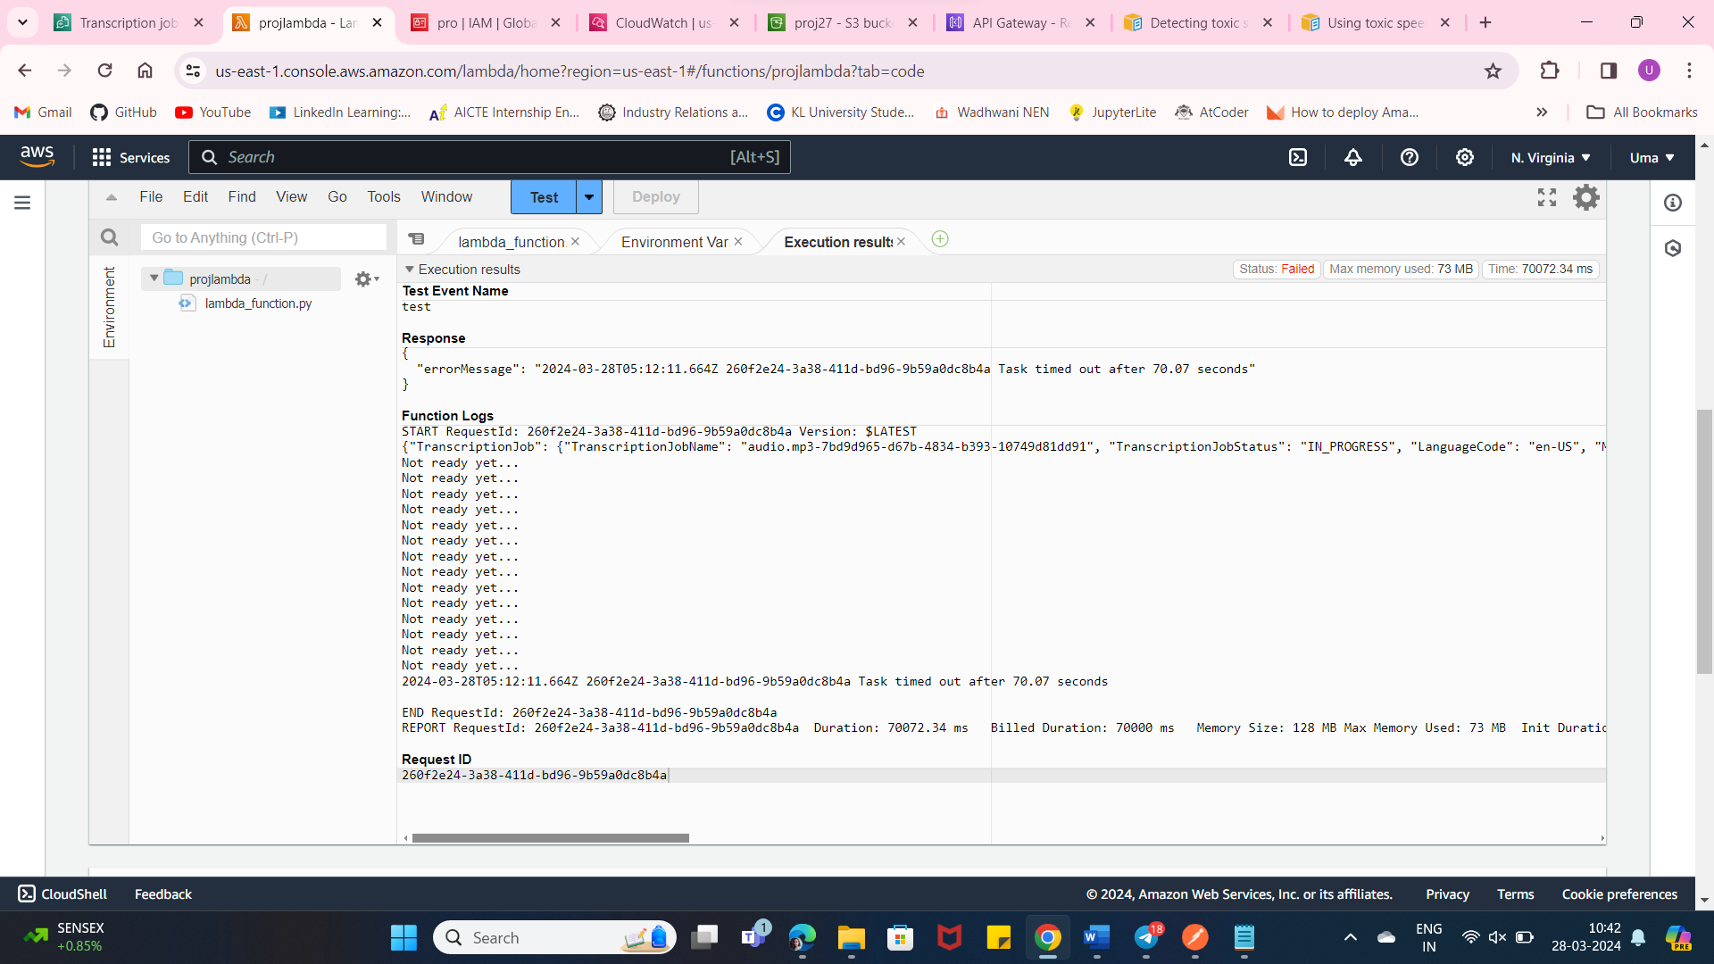

**The transcription job in AWS Transcribe:**

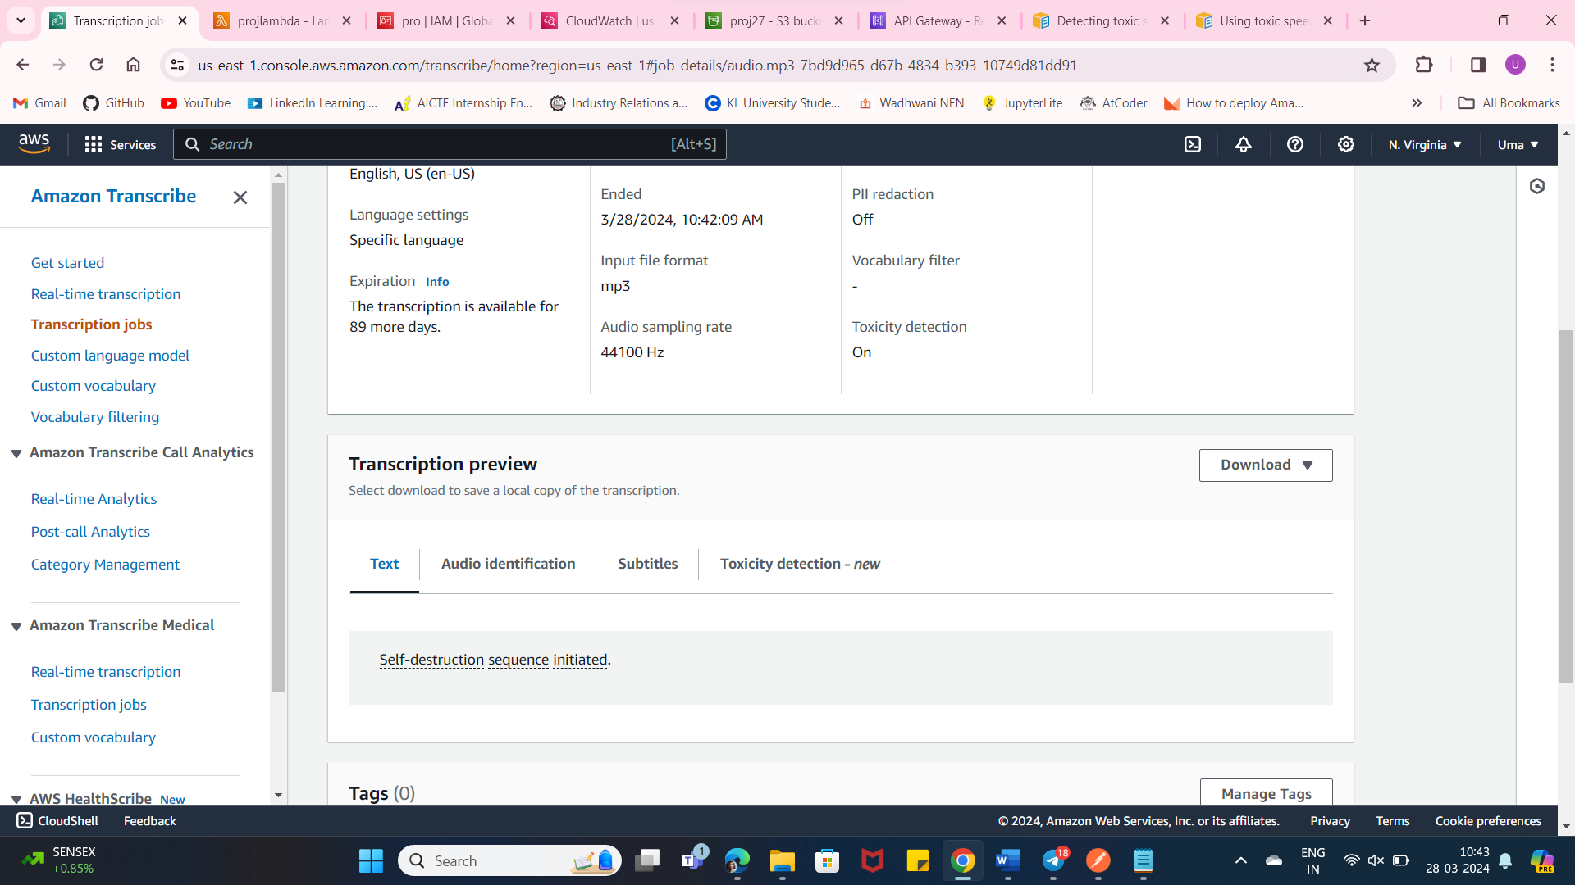

**Toxicity-detection:**

